**AI3021-IT IN AGRICULTURE**

**APPLICATIONS OF AI IN AGRICULTURE**

**ASSIGNMEENT - 1**

**Submitted By:**

**Name: Anisha A**

**Reg No: 950021104005**

**Dept: B.E- CSE**

**Year: IV**

**APPLICATIONS OF AI IN AGRICULTURE**

**INTRODUCTION:**

AI in agriculture is transforming the industry by improving efficiency, productivity, and sustainability. Making use of concepts like big data analytics, precision agriculture, and Internet of Things (IoT) to measure agriculture quantitatively Agriculture 4.0 envision improved crop yield with less exploitation of environment, low input use, and cost. Agriculture 4.0 emphasizes organization of farm inputs (fertilizers, seeds, farm fuel, and herbicides) through distributed management practices.

In a scenario where demand for agricultural produces keeps on increasing along with population growth and changes in lifestyle of people, production of enough material using limited resources is hard without the help of some innovative concepts. Man-machine interaction especially, Artificial Intelligence (AI) is the concept that can potentially transform the present day agriculture to a ‘produce more from less inputs’ model.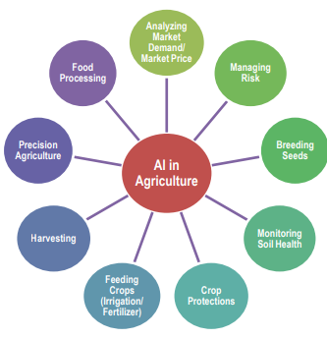

**PRECISION AGRICULTURE:**

Precision agriculture, also known as precision farming, is an innovative approach to managing farming practices that leverages technology to monitor, measure, and respond to variability in crops and fields. The goal of precision agriculture is to optimize agricultural inputs (such as water, fertilizers, and pesticides) and enhance productivity while minimizing waste, environmental impact, and costs. AI plays a significant role in advancing precision agriculture by providing data-driven insights and automating complex tasks.

* Optimize Inputs: Apply fertilizers, water, and pesticides only where needed, reducing waste and environmental impact.
* Monitor Crop Health: Detect diseases, pests, and nutrient deficiencies early through image analysis and sensors, allowing timely intervention.
* Maximize Yield: Use predictive analytics to forecast yields and make informed decisions about crop management.

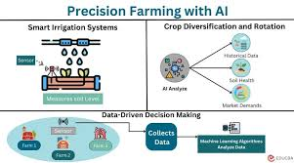

**Key Components of Precision Agriculture**:

* **Remote Sensing:** Use of drones, satellites, and aircraft equipped with sensors to capture detailed images and data on crop health, soil conditions, and environmental factors.
* **Ground Sensors:** In-field sensors measure soil moisture, temperature, nutrient levels, and other variables that influence crop growth.
* **GPS Technology:** Global Positioning Systems (GPS) enable precise mapping of fields and location-specific data collection.
* **Real-Time Crop Monitoring:** AI systems continuously monitor crop health using data from sensors and remote sensing, detecting issues like disease, pest infestations, or nutrient deficiencies early.
* **Crop Mapping:** Detailed maps of crop fields that show variations in soil and crop conditions, helping farmers tailor their management practices.
* **Machine Learning and AI:** AI algorithms process and analyze vast amounts of data collected from various sources to identify patterns, trends, and relationships that impact crop performance.

**HARVESTING:**

Yield prediction is a critical application of AI in agriculture, helping farmers and agricultural stakeholders forecast the amount of produce they can expect from their crops. Accurate yield prediction is essential for planning, resource management, market strategy, and reducing risks.

* AI uses machine learning algorithms to analyze vast amounts of data collected from various sources. These models learn from historical data and identify patterns that correlate with crop yields.
* AI integrates climate data such as temperature, rainfall, humidity, and sunlight to assess how weather conditions will affect crop growth and yield.
* AI evaluates soil properties, nutrient availability, and crop health to estimate how these factors will impact the final yield.

AI-driven yield prediction is transforming agriculture by providing farmers with the tools they need to optimize their operations, manage risks, and maximize profits. As AI technology continues to advance, yield predictions will become even more accurate, further enhancing the efficiency and sustainability of agricultural practices.

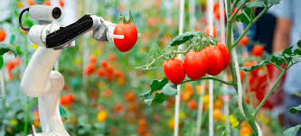

**MONITORING SOIL HEALTH:**

Monitoring soil health is a crucial aspect of sustainable agriculture, as healthy soil is fundamental to crop productivity, environmental quality, and overall agricultural sustainability. AI plays a significant role in enhancing the precision, efficiency, and effectiveness of soil health monitoring.

* **Soil Sensors:** Ground-based sensors measure various soil parameters such as moisture levels, temperature, pH, nutrient content (e.g., nitrogen, phosphorus, potassium), and electrical conductivity.
* **Remote Sensing:** Satellite and drone-based imagery are used to monitor large areas of farmland, providing data on soil conditions and vegetation health over time.
* **Soil Sampling:** Traditional soil sampling combined with AI-powered analysis allows for a detailed understanding of soil composition and health.

With the help of AI monitors we can essential soil nutrients (nitrogen, phosphorus, potassium) to ensure crops have the necessary resources for growth. It can recommend fertilization schedules and types based on nutrient deficiencies.

AI models track soil moisture levels to optimize irrigation practices, preventing over- or under-watering, which can harm soil structure and health

Maintaining the right pH level is critical for nutrient availability to plants. AI helps monitor and adjust soil pH by analyzing sensor data and suggesting corrective measures.

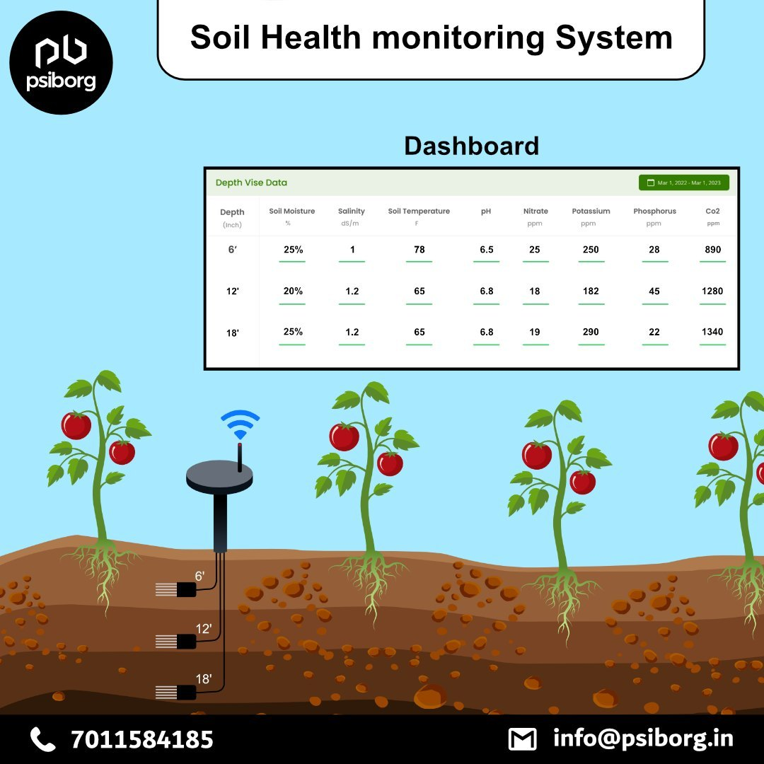

AI-powered soil health monitoring is a game-changer in agriculture, enabling farmers to maintain and improve the quality of their soil, which is essential for long-term productivity and environmental sustainability. By providing real-time data, predictive insights, and actionable recommendations, AI helps farmers manage their soil more effectively, ensuring the health of their land for future generations.

**FOOD PROCESSING:**

Food processing involves transforming raw ingredients into food products that are safe, palatable, and convenient for consumption. AI is increasingly being integrated into food processing to improve efficiency, safety, quality, and sustainability.

**Quality Control**

* **Image Recognition and Computer Vision:** AI systems equipped with cameras and sensors can inspect food products on production lines for defects, contamination, or irregularities. This ensures that only high-quality products reach the consumer.

**Food Safety**

* **Contamination Detection:** AI systems can detect contaminants such as pathogens, foreign objects, or chemicals in food products during processing, ensuring they meet safety standards.
* **Traceability:** AI enhances the traceability of food products from farm to fork, helping manufacturers quickly identify and address sources of contamination or recalls.

**Automation and Robotics**

* **Automated Sorting and Packaging:** AI-powered robots can sort food products based on size, shape, or quality, and package them efficiently. This reduces labor costs and increases throughput.

**Regulatory Compliance**

* **Labeling and Documentation:** AI automates the creation of accurate food labels that comply with regulatory requirements, including nutritional information and ingredient lists.
* **Compliance Monitoring:** AI systems ensure that food processing practices adhere to local and international food safety standards, reducing the risk of violations and penalties.

**CROP PROTECTION:**

Crop protection is a crucial aspect of agriculture that involves safeguarding crops from pests, diseases, weeds, and other harmful factors to ensure healthy growth and optimal yields. AI is increasingly being integrated into crop protection strategies, offering innovative solutions that enhance the efficiency, precision, and sustainability of these practices.

**Pest and Disease Detection**

* AI systems use image recognition technology to analyze pictures of crops and identify signs of pest infestations or diseases. Drones or mobile devices capture images, which are then processed by AI algorithms to detect issues at early stages.
* AI models predict the likelihood of pest or disease outbreaks based on historical data, weather conditions, and crop information. This allows farmers to take preventive measures before the problem escalates.

**Technologies:**

* **Variable Rate Technology (VRT):** AI systems can control pesticide application equipment to apply chemicals only where needed, reducing the overall use of pesticides and minimizing environmental impact. This targeted approach is based on real-time data and analysis.
* **Automated Spraying Drones:** Drones equipped with AI can autonomously spray pesticides on specific areas of a field where pests are detected, ensuring precise and efficient application.

**Weed Control:**

* **Robotic Weeding:** AI-powered robots can distinguish between crops and weeds using advanced sensors and image recognition. These robots can then remove weeds mechanically or apply herbicides directly to them, reducing the need for broad-spectrum herbicide application.
* **Selective Herbicide Application:** AI systems identify weed-infested areas and selectively apply herbicides, minimizing the amount of chemicals used and reducing the risk of herbicide resistance.

**Integrated Pest Management (IPM)**

* **Decision Support Systems (DSS):** AI-powered DSS platforms integrate data from various sources (e.g., weather, soil conditions, pest monitoring) to provide farmers with recommendations on the best crop protection strategies. This helps in implementing IPM practices that combine biological, cultural, and chemical controls.
* **Biological Control:** AI assists in the monitoring and release of beneficial organisms (e.g., predators or parasitoids) that naturally control pest populations, reducing the reliance on chemical pesticides.

**Disease Modeling and Simulation**

* **Scenario Analysis:** AI can simulate various scenarios based on different weather forecasts, farming practices, and disease management strategies to predict potential outcomes and guide decision-making.
* **Risk Assessment:** AI models assess the risk levels of various diseases based on current and forecasted conditions, helping farmers prioritize their disease management efforts.

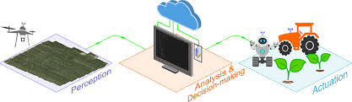

AI is revolutionizing crop protection by offering more precise, efficient, and sustainable solutions to manage pests, diseases, and weeds. By integrating AI into crop protection strategies, farmers can safeguard their crops, optimize resource use, and reduce environmental impact, leading to healthier crops and higher yields. As AI technology continues to advance, its role in crop protection will become even more vital in ensuring global food security and sustainable agriculture.

**BREEDING SEEDS:**

AI plays a significant role in the process of breeding seeds, accelerating the development of new, high-yield, and resilient crop varieties. Here’s how AI is transforming seed breeding:

* **Genetic Analysis**: AI can analyze the genetic makeup of plants to identify traits associated with higher yields, disease resistance, and climate adaptability. This allows breeders to select the best candidates for crossing.
* **Predictive Breeding**: Machine learning models can predict the performance of new plant varieties by analyzing genetic data, environmental conditions, and historical yield data. This speeds up the breeding process by focusing on the most promising genetic combinations.
* **Automated Trait Identification**: AI-powered systems can automatically identify and measure plant traits at scale, which is much faster than traditional methods that rely on manual observations.
* **AI-Driven Crosses**: AI can simulate crossbreeding scenarios to predict the outcomes of different genetic combinations. This helps breeders make informed decisions about which plants to cross to produce the desired traits.
* **Reducing Trial and Error**: Traditional breeding involves a lot of trial and error. AI reduces this by narrowing down the most effective crossbreeding strategies, saving time and resources.
* **Reducing Input Needs**: AI can help in developing seed varieties that require fewer inputs like water, fertilizers, and pesticides, contributing to more sustainable agricultural practice
* **Maximizing Yield Potential**: By selecting traits that maximize yield under specific conditions, AI ensures that new seed varieties can produce more food with fewer resources.
* AI’s integration into seed breeding is revolutionizing the way new crop varieties are developed, making the process faster, more efficient, and better suited to the challenges of modern agriculture.

**ANALYZING MARKET DDEMANDS AND RISK MANAGEMENT:**

Analyzing market demands is a critical aspect of any business strategy, including in agriculture, retail, technology, and beyond. Here’s how AI and data-driven techniques are employed to analyze market demands:

1. **Data Collection and Aggregation:**

* Customer Data: AI collects and aggregates data from various sources such as sales records, social media, online searches, and customer feedback to identify trends and patterns in consumer behavior.
* Market Surveys: Automated tools conduct surveys and analyze responses in real-time, providing insights into customer preferences, needs, and purchasing intentions.

**2. Predictive Analytics:**

* Trend Forecasting: AI models use historical data to predict future trends in consumer demand. This includes analyzing past sales data, seasonal patterns, and emerging market trends.
* Demand Prediction: Machine learning algorithms can predict the demand for specific products or services, helping businesses optimize inventory levels and reduce waste.

**3. Sentiment Analysis**

* Social Media Monitoring: AI tools analyze social media platforms to gauge public sentiment towards products, brands, and industry trends. This helps in understanding customer opinions and predicting market movements.

**4. Competitor Analysis**

* Market Positioning: AI tools can analyze competitors’ offerings, pricing strategies, and marketing campaigns to understand their market position and predict their impact on overall demand.

**5. Customer Segmentation**

* Targeted Marketing: AI-driven customer segmentation identifies different customer groups based on demographics, behavior, and preferences. This allows businesses to tailor their marketing strategies to specific segments, optimizing customer engagement and sales.
* Personalization: AI enables personalized recommendations and offers by analyzing individual customer data, increasing the likelihood of purchase and enhancing customer loyalty.

**6. Real-Time Market Analysis**

* Dynamic Pricing: AI-driven dynamic pricing models adjust prices in real-time based on current demand, competitor pricing, and market conditions, maximizing revenue and market share.
* Supply Chain Management: AI monitors and responds to changes in market demand in real-time, ensuring that supply chains are agile and responsive to market fluctuations.

**8. Customer Experience Enhancement:**

* Feedback Analysis: AI analyzes customer feedback across various channels to identify pain points, preferences, and emerging demands. This helps in improving products and services to better meet market needs.

**9. Economic Indicators:**

* **Macro and Microeconomic** **Data**: AI models incorporate economic indicators like GDP growth, inflation rates, and consumer spending to forecast market demand and adjust business strategies accordingly.

**Benefits of AI-Driven Market Demand Analysis**

* **Accuracy**: AI enhances the accuracy of demand forecasts by considering a wide array of data points and using advanced algorithms.
* **Efficiency**: Automating data collection and analysis speeds up the process, allowing businesses to react quickly to changes in market demand.
* **Competitive Advantage**: Businesses that effectively analyze and respond to market demand can stay ahead of competitors by meeting customer needs more precisely.

By leveraging AI in market demand analysis, businesses can make more informed decisions, optimize their operations, and better align their products and services with customer needs.

**RISK MANAGEMNT:**

Risk management is the process of identifying, assessing, and prioritizing potential risks to an organization or project, followed by implementing strategies to minimize or mitigate their impact. It involves a systematic approach to recognizing uncertainties that could negatively affect objectives, whether they stem from financial markets, legal liabilities, operational failures, or natural disasters.

Effective risk management not only involves preparing for potential threats but also exploiting opportunities that arise from those uncertainties. By understanding and managing risks, organizations can protect their assets, ensure regulatory compliance, and enhance decision-making processes, ultimately contributing to long-term stability and success.

**Market Risk Analysis:**

* + - AI helps in identifying potential risks and opportunities in the market by analyzing economic data, political events, and global trends.

**POTENTIAL OF AI IN INDIAN AGRICULTURE:**

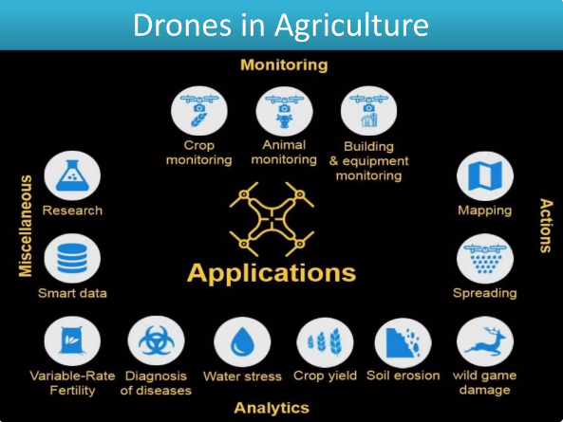

**Agricultural Growth driven by IoT:**

AI and IoT (sensors) can be used to create intelligent systems that can be embedded in machines to make it work with higher accuracy. These technologies help in the spatial and temporal evaluation of individual plots or plants.

**Image-based Insight Generation:**

Using the satellite and drone imagery real-time alerts can be generated in precision farming. These artificial intelligence systems not only save time but also increase safety and reduce potential human error while improving effectiveness.

**Computer Vision:**

Computer vision technology can be used to grade the agricultural produce (grading of fruits and vegetables), enhance the quality of produce, and fetch high market values and profit to farmers. This will help to reduce post-harvest losses of perishable commodities. Also, the technology can make use in the procurement, storage, and distribution of food grains.

**Identification of Optimal Agronomic Product Mix:**

AI helps to generate farm specific recommendations analyzing different parameters like soil health, weather forecast, type of seeds, and pest infestation in the area. Though the recommendation include best choice of crops and technologies for a specific farm, it can be further personalized based on the farm's requirements, local conditions, and past data on successful farming.

**Crop Health Monitoring Systems:**

Remote sensing techniques, hyperspectral imaging and AI build crop health monitoring systems that can monitor crop health from both time and effort perspectives. AI facilitates identification of pests, diseases, and weeds problems and automates the management of these problems. AI-enabled agricultural production systems also predict future situations and issue advisories for sowing, pest control and commodity pricing.

**Smart Irrigation Systems:**

Smart irrigation involves providing the right quantity of water at the right place at the right time for the right crop so as to improve crop yield. Using sensor based automated irrigation system issues associated with the low irrigation efficiency of Indian agriculture (around 38%) can be resolved to a greater extent. Also, automated irrigation scheduling is possible using machines trained on historical weather patterns and soil quality of the locality along with the kind of crops to be grown.

**Agriculture Risk Management:**

Climate change issues such as increased temperature, erratic rainfall pattern and other associated problems have increased the importance of the AI system in agriculture in recent years. AI based technologies support farmers in the management of risk and uncertainty in agriculture by facilitating the preparedness of farmers to handle the crisis efficiently.

**Natural Language Processing (NLP) for AgroAdvisory:**

India is a multi-lingual society and majority of farmers are illiterate. A lot of content failed to reach the desired people due to lack of human-resource to convert it to the end-user's language. This gap can be effectively filled through natural language processing

**Attract Youth to Agriculture:**

Decreasing agriculture labor force due to migration of youth to other jobs can be well addressed using AI based agriculture. AI based technologies will attract the tech-savvy youth, reduce drudgery and save natural resources and agriculture.